**Research questions and Key Findings**

**Description About the Data**

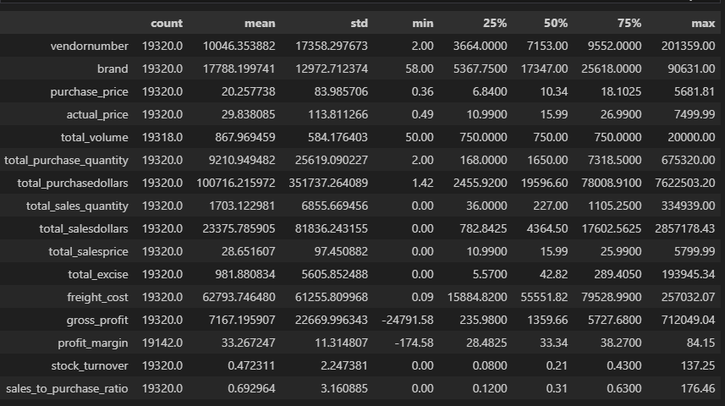

**Graphs presenting outliers in the data with help of Box plot**

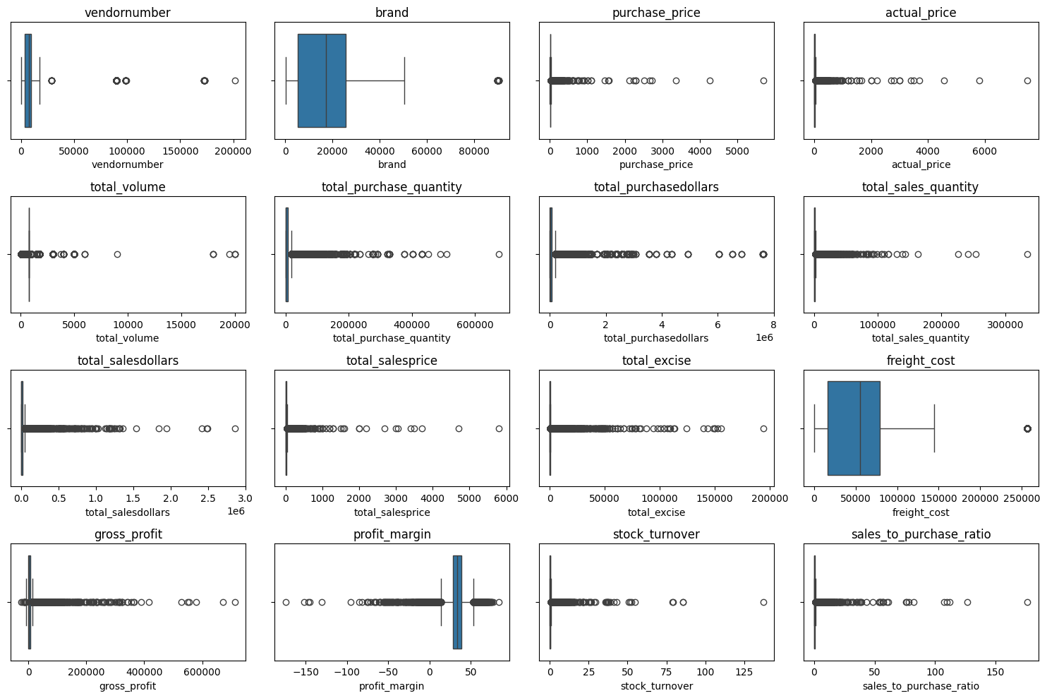

**Summary Statistics Insights:**

**Negative & Zero Values:**

• Gross Profit: Minimum value is -24791.58, indicating losses. Some products or transactions may be selling at a lower than the purchase price.

• Profit Margin: Has a minimum of -174.58 which suggests cases where revenue 0 or even lower than costs.

• Total Sales Quantity & Sales Dollars: Minimum values are 0, meaning some products were purchased but never sold. These could be slow moving or obsolete stock.

**Outliers Indicated by High Standard Deviations:**

• Purchase & Sales: Their quantity and total dollars are significantly higher than the mean

products.

• Freight Cost: Huge variation, from 0.09 to 257032.07, suggests logistics inefficiencies or bulk shipments.

• Stock Turnover: Ranges from 0 to 137.25, and the mean is 0.47 implying most products remain in stock indefinitely. Value more than 1 indicates that the Sold quantity for that product is higher than purchased quantity due to either sales are being fulfilled from older stock.

**Correlation heatmap**

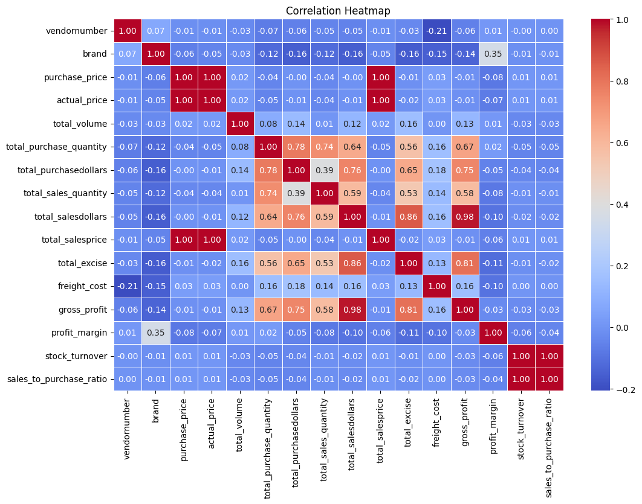

**Correlation Insights**

• PurchasePrice has weak correlations with TotalSalesDollars (-0.00) and GrossProfit (-0.01), suggesting that price variations do not significantly impact sales revenue or profit.

• Slightly Negative correlation between profit margin & total sales price (-0.10) suggests that as sales price increases, margins slightly decrease, possibly due to competitive pricing pressures.

• StockTurnover has weak negative correlations with both GrossProfit (-0.03) and ProfitMargin (-0.04), indicating that faster turnover does not necessarily result in higher profitability.

**Problem Statement Questions**

1. 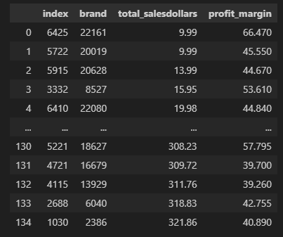**Identify Brands that needs Promotional or Pricing Adjustments which exhibit lower sales performance but higher profit margins.**

Total of 135 brands exhibit lower sales but higher profit margins, which could benefit from targeted marketing, promotions, or price optimizations to increase volume without compromising profitability.

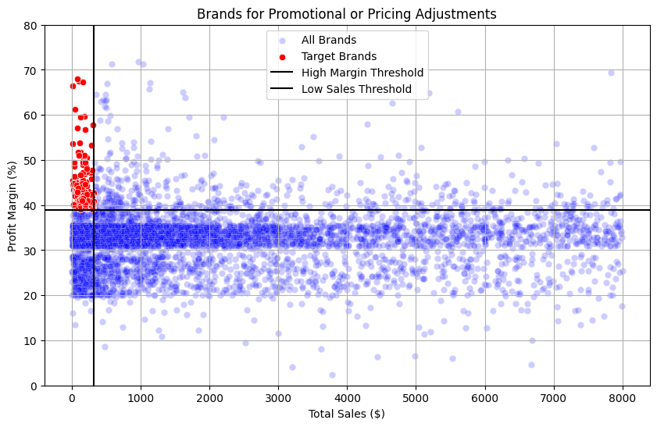

1. **Which vendors and brands demonstrate the highest sales performance?**

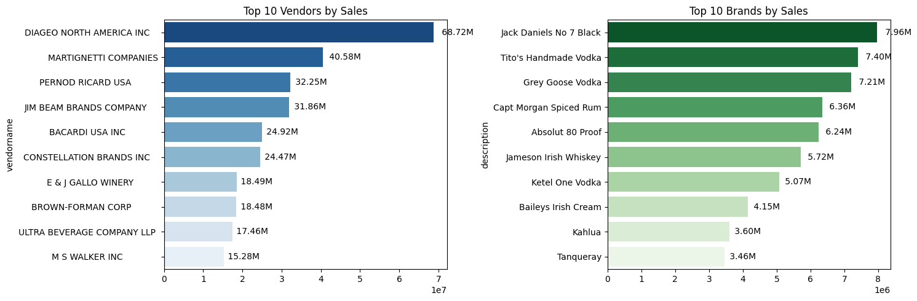

**Top 10 Vendors by Sales**

* **Diageo North America Inc** is the clear leader, with sales of **68.72M**, far surpassing the second-highest vendor.
* **Martignetti Companies** and **Pernod Ricard USA** are in 2nd and 3rd places with **40.58M** and **32.25M**, respectively.
* The gap between Diageo and the next vendor is huge (over 28M more than Martignetti).
* Other notable vendors include **Jim Beam Brands Company**, **Bacardi USA Inc**, and **Constellation Brands Inc**, each ranging between **24M–32M**.
* The bottom three vendors in the top 10 (Brown-Forman, Ultra Beverage, M S Walker) are significantly smaller, with sales **under 19M**.
* This indicates that the vendor market is **heavily dominated by a few players**, especially Diageo.

**Top 10 Brands by Sales**

* **Jack Daniel’s No 7 Black** is the top-selling brand at **7.96M**, slightly ahead of **Tito’s Handmade Vodka** (**7.40M**) and **Grey Goose Vodka** (**7.21M**).
* Rum and whiskey also appear strongly: **Captain Morgan Spiced Rum (6.36M)** and **Jameson Irish Whiskey (5.72M)**.
* Vodka dominates the list overall (Tito’s, Grey Goose, Absolut, Ketel One, and Tanqueray).
* Cream liqueurs and specialty brands like **Baileys Irish Cream (4.15M)** and **Kahlúa (3.60M)** also make it into the top 10.
* The brand market is **more balanced** than the vendor market; while Jack Daniel’s leads, the difference between 1st and 10th place is only about **4.5M**.

**Cross-Insights**

* Vodka is the most represented spirit type among top brands, signaling **high consumer preference**.
* Whiskey also performs strongly (Jack Daniel’s, Jameson), showing its solid market demand.
* Even though some vendors (like Martignetti Companies) rank high overall, they don’t have an individual brand in the top 10, suggesting their strength comes from **wide distribution across many brands** rather than one flagship product.

1. **Which vendors contribute the most to total purchase dollars?**

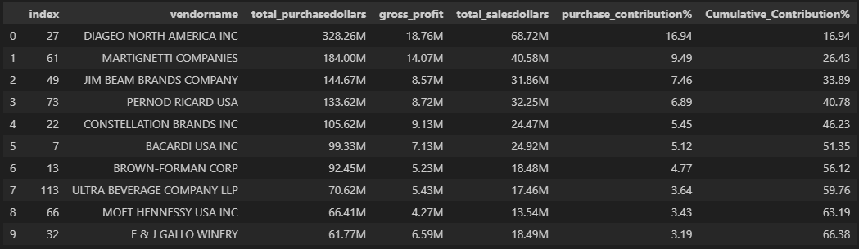

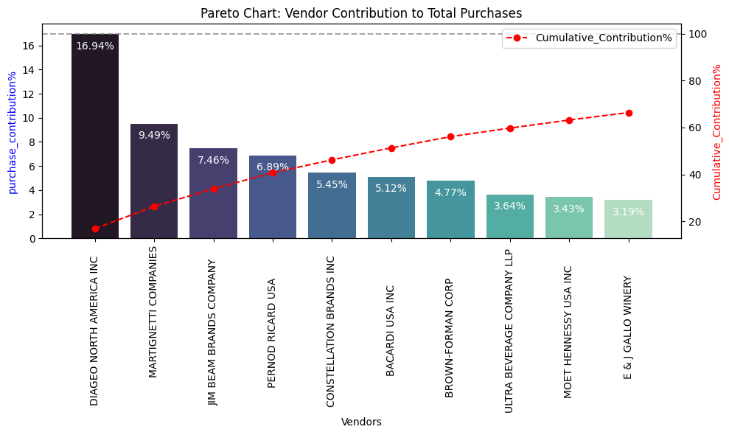

**Cumulative Insights**

* The top 3 vendors (**Diageo, Martignetti, Jim Beam**) together make up **33.89%** of total purchases.
* The top 5 vendors (adding Pernod Ricard and Constellation) together account for **46.23%** of purchases → showing a concentrated supplier market.
* By the time we include the top 10 vendors, the cumulative contribution reaches **66.38%,** meaning **two-thirds of total purchase dollars** come from just 10 companies.

This indicates high dependency on a small number of vendors, especially Diageo. Any disruption in their supply would significantly impact on the overall business.

1. **How much of total procurement is dependent on the top vendors?**

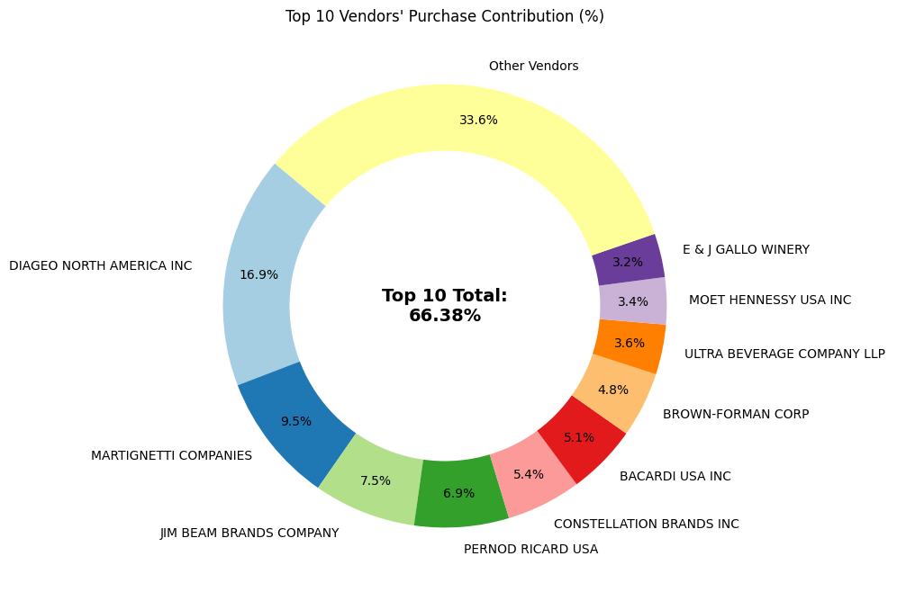

The top 10 vendors contribute 65.69% of total purchases, while the remaining vendors contribute only 34.31%. This over-reliance on a few vendors may introduce risks such as supply chain disruptions, indicating a need for diversification.

1. **Does purchasing in bulk reduce the unit price, and what is the optimal purchase volume for cost savings?**

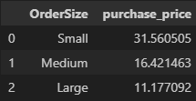**\**

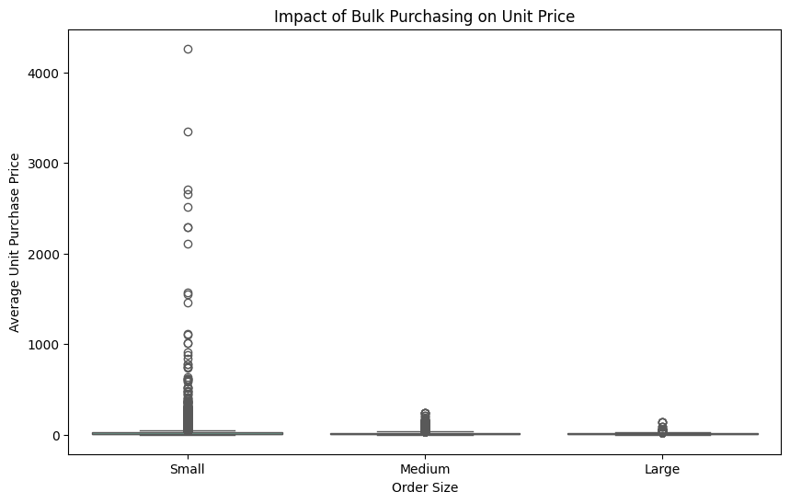

• Vendors buying in bulk (Large Order Size) get the lowest unit price ($11.17 per unit), meaning higher margins if they can manage inventory efficiently.

• The price difference between Small and Large orders is substantial (-74% reduction in unit cost.

• This suggests that bulk pricing strategies successfully encourage vendors to purchase in larger volumes, leading to higher overall sales despite lower per-unit revenue.